
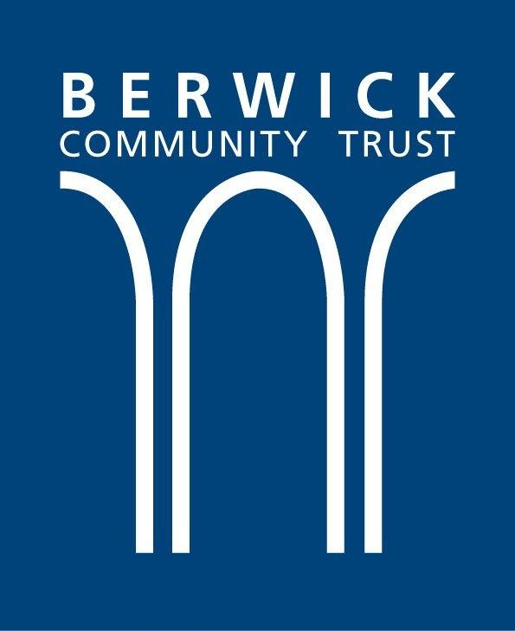

Lions House Fund - Guidance Notes

What is the Lions House Fund?
The Lions House Fund, set up by (the Donor), is set up to support and encourage residents’ efforts to establish and build successful business ventures that enhance services to residents and visitors in Berwick upon Tweed. The Lions House Fund aims to support growth within the local economy by improving and encouraging the diversity of businesses within the town.

Who Can Apply?
Individuals, small businesses, CICs and charitable organisations can apply.
The applicant must be located in the TD15 postcode and the commercial activity must take place within Berwick upon Tweed, Tweedmouth, Spittal or Ord.
Statutory agencies and local authorities are not eligible.
Examples that could be funded include training, equipment, etc. Salaries are not eligible.

Priorities and principles of fund
The Fund is flexible and is willing to consider imaginative and innovative ideas that support the development of new and growing businesses in the town.

The Fund is particularly interested in hearing from applicants interested in setting up new businesses that support the forthcoming River Tweed Trail.

Allocations will be made with the intention of maximizing impact. There is no specific number of grants that will be funded.

The size of the awards depends upon the funds available and the quality of applications. The maximum award that can be made is £5,000.

For larger projects please contact us via email.

Initially the fund is for a two year pilot period.

Expectations, Timescales and Follow-ups
Timescales for the scope of grants will be discussed on an individual basis.
Monitoring of progress towards the goal identified in the grant application will take place at an agreed end point.
Evidence of expenditure related to the grant must be provided.
Grant fund applications may have payments made at different times. This may be staggered payments, payment at commencement or payment on completion. This will be notified by the Trust when terms and conditions are agreed.
The Trust may request photography opportunities to be used in the promotion of the fund. Consent will be sought in this circumstance.

How to Apply
The completed application form should be emailed to bmurray@berwicktrust.org.uk along with copies of your:
- governing document or constitution (if relevant)
- most recent independently examined or audited accounts
- evidence of an appropriate bank account
- any other relevant supporting information e.g. business plan

Attachments should be in pdf or Word format.

If you do not have, or cannot make, electronic copies of these documents, paper copies should be sent to:
Lions House Fund
Berwick Community Trust
The William Elder Building
56-58 Castlegate
Berwick-upon-Tweed
TD15 1JT

Data Protection
When completing an application form you may be asked for personal information.
The personal information provided will be used by the Trust to manage its relationship with you, help us deliver the services you have asked to use, or to send you information you have requested.
Information you supply in connection with a grant application and any funding arising from that application will be treated in confidence and in accordance with the principles of the General Data Protection Regulations (GDPR).
We reserve the right to publish the names and brief details of the projects we make awards to.

